The Colors Game:
The second game is called the Colors Game. You may remember doing a game like this during one of your previous study visits. For this one we will show you a colored word in the middle of the screen. You will need to select the COLOR of letters spelling the word while ignoring the meaning of the word itself. The word will always be the name of a color, but that doesn’t matter. The only thing that matters is the COLOR of the letters spelling out the name. For this game, you will use all 4 buttons.
At first the screen will have a plus sign on it, and as before you should look at the plus sign and wait. Soon it will change to the screen with the colored word in the middle, like in this picture [visual 5]. You will see four words below it in white. The four words match with the four buttons you have your fingers on. They will always be in the same order. So, red is the first button with your pointer finger, green is the second button with your middle finger, and so on. We want you to press the button that matches to the COLOR of the letters spelling out the word in the middle of the screen.
Sometimes the word will be shown in the same color it names, sometimes it will be different [visual 6]. Remember, always select the color of the letters spelling the word; it doesn’t matter what the word says!
If you are correct, you will get a tick [visual 7]. If you are incorrect, you will get an “x” [visual 8]. If you are incorrect, you will get a tick showing you the correct answer. You will have a limited amount of time to respond, so be sure to respond as quickly as you can without making mistakes. You will go through several sets of words with some resting time (just a plus sign) in between each set.
Any questions? Ready to practice?

Ok, we have now finished practicing our first two games and we have two more to go.

+

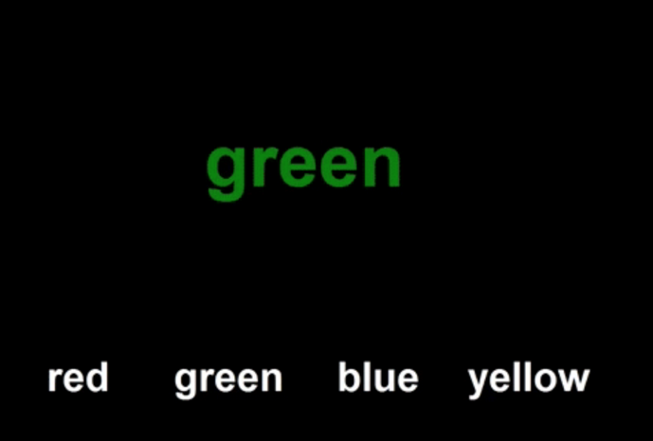

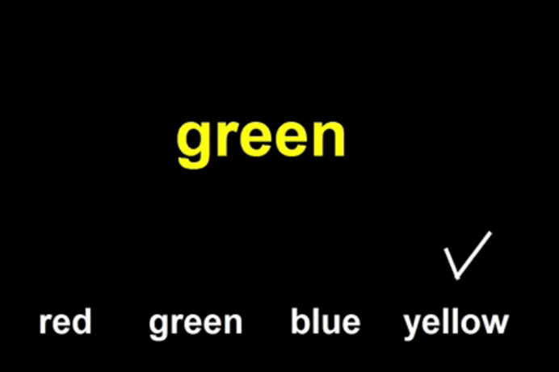

x

